**Project Report On**

# Project Title

***Submitted By:***

**Your Name**

***In partial fulfillment for the award of the degree of***

## YOUR DEGREE NAME

***In***

## COMPUTER SCIENCE & ENGINEERING

**YOUR UNIVERSITY NAME**

DATE-YEAR

# STUDENT’S DECLARATION

We the students of VIII semester B.Tech. Your University Name____, ABC(your name) declare that he technical Project work entitled “**ONLINE SHOPPING SYSTEM”** has been carried out and submitted in the partial fulfilment of the course requirements for the award of degree in B.Tech. Computer Science Engineering at ________during the academic year 2023-24. The matter submitted in the synopsis has been not submitted to any other university or institutions for the award of any other degree or diploma in the concerned stream.

### Your name

**Place: Date:**

# CERTIFICATE

This is to certify that the dissertation report entitled, “Online Shopping System” submitted by your name , India, is a record of bonafide project work carried out by them under our supervision and guidance and is worthy of consideration for award of Degree of Bachelor of Technology in Computer Science Engineering of the Institute.

**Project Guide:** Mr. __________

…………………………. Assistant Professor

Department Of Computer science engineering __________

**Project Coordinator:** Mr. ___________

Assistant Professor

Department Of Computer Science Engineering ___________

**Head Of The Department:** _____________

HOD / Asst. Professor

Department Of Computer Science Engineering ____________

# ABSTRACT

An online shopping system that permits a customer to submit online orders for items and/or services from a store that serves both walk-in customers and online customers. The online shopping system presents an online display of an order cut off time and an associated delivery window for items selected by the customer. The system accepts the customer's submission of a purchase order for the item in response to a time of submission being before the order cut off time. The online shopping system does not settle with a credit supplier of the customer until the item selected by the customer is picked from inventory but before it is delivered. Therefore, the customer can go online and make changes to the order. In addition, available service windows are presented to the customer as a function of customer selected order and service types and further, the order picking is assigned in accordance with a picker's preference. When ordering goods, many shopping systems provide a virtual shopping cart for holding items selected for purchase. Successive items selected for purchase are placed into the virtual shopping cart until a customer completes their shopping trip. Virtual shopping carts may be examined at any time, and their contents can be edited or deleted at the option of the customer. Once the customer decides to submit a purchase order, the customer may print the contents of the virtual shopping basket in order to obtain a hard copy record of the transaction.

# ACKNOWLEDGEMENT

We take immense pleasure in thanking Honorable **“Mr. Bhupesh Joshi”** (Assistant Professor, CSE, GEHU Bhimtal Campus) for having permitted me to carry out this project work with his excellent and optimistic supervision. This has all been possible due to his novel inspiration, able guidance and useful suggestions that helped me to develop as a creative researcher and complete the research work, in time.

Words are inadequate in offering my thanks to GOD for providing me everything that I need. I again want to extend thanks to our President **“Prof. Dr. Kamal Ghanshala”** for providing us all infrastructure and facilities to work in need without which this work could not be possible.

Many thanks to Professor **“Dr. Your Professor name”** (HOD-CSE, GEHU), **“Mr. Your associate Proffer name”** (Associate Professor, CSE, GEHU), and other faculties for their insightful comments, constructive suggestions, valuable advice, and time in reviewing this thesis.

Finally, yet importantly, I would like to express my heartiest thanks to our beloved parents, for their moral support, affection and blessings. I would also like to pay my sincere thanks to all my friends and well-wishers for their help and wishes for the successful completion of this research.

**TABLE OF CONTENTS**

Declaration 2

Certificate 3

Acknowledgement 5

Abstract 4

Table of Contents 6-7

List of Figures 8

List of Tables 8

List of Abbreviations 9

CHAPTER1 INTRODUCTION 10

* 1. Motivations 10
  2. Problem Statement 10
  3. Objectives and Research Methodology 11
  4. Project Organization 11

CHAPTER 2: PROPOSED SYSTEM 14

2.1 History 14

CHAPTER 3: SPECIFIC REQUIREMENTS 15

3.1 External Interface Requirement 15

CHAPTER 4: S/W AND H/W REQUIREMENTS (UP TO FULLEST EXTENT)

................................................................................................... 16

* 1. Functional Requirement 16
  2. Non- Functional Requirement 17
  3. Security Requirement 17
  4. Data Requirement 18

CHAPTER 5: USE CASES 19

* 1. List of Actors 19
  2. Constraints 20
  3. List of Use Cases 21
  4. System Use Case Diagram… 22
  5. Extended Use Cases 23

CHAPTER 6: DFD (AT LEAST UP TO 2 LEVEL) 24

* 1. DFD Level 0 24
  2. DFD Level 1 25
  3. DFD Level 2… 26

CHAPTER 7: DATABASE DESIGN (APPLICABLE IN CASE THE PROJECT HAS DBMS AT BACKEND) 27

7.1 Database Design (Applicable in case the project has DBMS at backend)

................................................................................................... 29

CHAPTER 8: ER DIAGRAM 30

8.1 ER diagram 30

CHAPTER 9: SRCREENSHOTS 31-36

CHAPTER 10: TESTING STRATEGIES 36-39

CHAPTER 11: RESULT/OUTPUT/STATISTCS 40

CHAPTER 12: CONCLUSION 42

CHAPTER 13: FUTURE WORK 43

REFERENCES 44

# List of Figures

Figure 1 Use case Diagram 20

Figure 2 DFD level 0 24

Figure 3 DFD level 1… 25

Figure 4 DFD level 2… 26

Figure5 Database 27

Figure6 E-R Diagram… 28

Figure7 Home-page 29

Figure8 Product-Page 30

Figure9 Sign In-Page 32

Figure10 Sign Up-Page 33

Figure11 Admin Panel 34

# List of Tables

Table 1: Table of acronyms and definitions .....................................................

Table 2: Data Dictionary 1 ................................................................................

Table 3: Data Dictionary 2 ................................................................................

Table 4: Data Dictionary 3................................................................................

Table 5: Data Dictionary 4................................................................................

Table 6: Data Dictionary 5 .................................................................................

Table 7: Data Dictionary 6...................................................................................

Table 8: Test case 1 .............................................................................................

Table 9: Test case 2 ............................................................................................

Table 10: Test case 3 ...........................................................................................

Table 11: Test case 4 ............................................................................................

Table 12: Test case 5 ............................................................................................

Table 13: Test case 6 ……………………………………………………………

# List of Abbreviations

Provide definitions or references to all the definitions of the special terms and acronyms used within this document .

|  |  |
| --- | --- |
| **ACRONYMS** | **DEFINITION** |
| OSS | Online Shopping system |
| DFD | Data flow diagram |
| ERD | Entity Relationship Diagram |
| Admin | A person who manages the entire system. |
| Customer | A person who can find the products. |
| Management | Who take cares that site goes smoothly. |
| Web-based application | An application that runs on the Internet. |
| Login | A user identification number to enter the system |

# CHAPTER 1 INTRODUCTION

## MOTIVATION

Online shopping has transformed into one of the most popular channels, both for consumers and suppliers. It provides a broad range of benefits such as 24/7 opportunity to purchase, online catalogues, comparative pricing, cost efficiency, less time consuming and a lot more. These are the reasons why I believe that this channel is likely to grow in greater popularity in the future. In this aspect I focus on recognizing the motivational factors of online shopping. Once these factors are identified, online sellers would be able to enhance the popularity of this distribution channel at greater depth because in my project I will try to find the forces that drive consumers to buy online. I believe that in the development of the future characteristics of e-commerce, future patterns of buying behaviour would play a significant role. Furthermore my research would reveal emerging trends which can be considered by online companies in the development of their promotions.

## PROBLEM STATEMENT

This projects aims to develop an online shopping for customers with the goal so that it is very easy to shop your loved things from a extensive number of online shopping sites available on the web. With the help of this you can carry out an online shopping from your home. Here is no compelling reason to go to the crowed stores or shopping centers during festival seasons. You simpy require a PC or a laptop and one important payment sending option to shop online.To get to this online shopping system all the customers will need to have a email and password to login and proceed your shopping.

## OBJECTIVE

The objective of the project is to make an e-commerce website to purchase items in an existing shop. In order to build such an e-commerce website, web support is to be provided. A complete and efficient website which can provide the online shopping experience is the basic objective of the project. The data in a centralized way which is available to all the event managers. Historical data is easy to manage in database. Participants can register for any happening event from anywhere. Event manager can keep records of participants.

## PROJECT ORGANIZATION

**Online shopping** is a form of [electronic commerce](https://en.m.wikipedia.org/wiki/Electronic_commerce) which allows consumers to directly

buy [goods](https://en.m.wikipedia.org/wiki/Good_(economics)) or [services](https://en.m.wikipedia.org/wiki/Service_(economics)) from a seller over the [Internet](https://en.m.wikipedia.org/wiki/Internet) using a [web browser.](https://en.m.wikipedia.org/wiki/Web_browser) Consumers find a

product of interest by visiting the [website](https://en.m.wikipedia.org/wiki/Website) of the retailer directly or by searching among alternative

vendors using a [shopping search engine,](https://en.m.wikipedia.org/wiki/Shopping_search_engine) which displays the same product's availability and pricing

at different e-retailers. As of 2023, customers can shop online using a range of different computers and devices, including [desktop computers,](https://en.m.wikipedia.org/wiki/Desktop_computer) [laptops,](https://en.m.wikipedia.org/wiki/Laptop) [tablet computers](https://en.m.wikipedia.org/wiki/Tablet_computer) and [smartphones.](https://en.m.wikipedia.org/wiki/Smartphone)

An online shop evokes the physical analogy of buying [products](https://en.m.wikipedia.org/wiki/Product_(business)) or services at a regular ["bricks-](https://en.m.wikipedia.org/wiki/Brick_and_mortar_business)

[and-mortar"](https://en.m.wikipedia.org/wiki/Brick_and_mortar_business) [retailer](https://en.m.wikipedia.org/wiki/Retailing) or [shopping center](https://en.m.wikipedia.org/wiki/Shopping_center); the process is called business-to-consumer (B2C) online

shopping. When an online store is set up to enable businesses to buy from another businesses, the process is called [business-to-business](https://en.m.wikipedia.org/wiki/Business-to-business) (B2B) online shopping. A typical online store enables the

customer to browse the firm's range of products and services, view photos or images of the products, along with information about the product specifications, features and prices.

# CHAPTER 2 PROPOSED SYSTEM

## 2.1 HISTORY

The idea of online shopping predates the [World Wide Web.](https://www.newworldencyclopedia.org/entry/World_Wide_Web) A technology for real-time transaction

processing from a domestic television, based on Videotext, was first demonstrated in 1979 by Michael Aldrich, who designed and installed systems in the UK, including the first Tesco pilot system in 1984. The first business-to-business (B2B) computer network was created by Thomson Holidays in 1981.

In 1990 Tim Berners-Lee created the first World Wide Web server and browser. In 1992 Charles Stack created the first online bookstore, Book Stacks Unlimited (Books.com), two years before Jeff Bezos started Amazon.com. In 1994 other advances took place, such as online banking and the opening of an online pizza shop by Pizza Hut. During that same year, Netscape introduced SSL encryption (Secure Sockets Layer) of data transferred online, which has become essential for secure online shopping. In 1995 Amazon expanded its online shopping, and in 1996 eBay appeared.

# CHAPTER 3: SPECIFIC REQUIREMENTS

## External Interface Requirements

* + 1. **User Interfaces**

Each part of the user interface intends to be as user friendly as possible. The fonts and buttons used will be intended to be very fast and easy to load on web pages. The pages will be kept light in space so that it won’t take a long time for the page to load.

## Software Interfaces

* + - * Operating System : Unix, Linux, Mac, Windows 10 etc..
      * Development tool : Spring boot :,React js, JavaScript, HTML,CSS.
      * Database : MySQL

## Communication Interface

The Website Order system shall display the contact information of seller from that buyer can contact seller and buy that product.

# CHAPTER 4: S/W AND H/W REQUIREMENTS

## FUNCTIONAL REQUIREMENTS

* + 1. **Registration:**
       - To enter into this site user has to register himself first. Requirements of registration are user name, first name, last name, email-id, password, repeat password, address, mobile number.

## User Login:

* + - * The System provides facility to login into the system.
      * Enter username and password.
      * User Profile page appears.

## Forgot Password:

* + - * The user can send reset link to the mail id to reset password.
      * Input: Email id.
      * Output: Reset link send to Email id.

## Logout:

* + - * The system provides the facility to logout from the site
      * . Input : Select logout option
      * Processing : User will logout

## NON- FUNCTIONAL REQUIREMENTS

* + 1. **Performance Requirements:**
       - The system need to be reliable.
       - If unable to process the request then appropriate error message.
       - Web pages are loaded within few seconds.

## Safety Requirements:

* + - * The details need to be maintained properly.
      * Users must be authenticated .
      * The database must be kept backed up.

## Security Requirements:

* + - * After entering the password and user id the user can access his account.
      * The details of user must be safe and secure.

# DATA REQUIREMENT

* Minimum 1GB needed to store our database.
* 512MB RAM is also needed to install our whole system.

# CHAPTER 5: USE CASES

* 1. **List of Actors**

Following are the actors;

* + 1. **Organizer/Manager:**

Organizer is responsible for planning events and ensuring that they run as smoothly as possible.

## Administrator:

Processing sponsors and events bookings. Chasing up calls.

# Constraints

The constraints are;

* Convenience is the best and important part of doing shopping online as people can buy things by just sitting at home and spending some time on the desktop or mobile with internet access.
* You can find the products on the internet very easily by just visiting the sites than going to the local shopping store to find the products.
* To get important notification through E-mail, user must have to provide and email address.
* Shopping online gives an opportunity to buy a wide range of products of your favorite brands and choices.
* Comparisons of the products prices of your choice can be done by just visiting various e-commerce site.
* We work as a mediator between product and customers.

# List of Use Cases

Following are the use cases;

## Registration:

To enter into this site user has to register himself first. Requirements of registration are first name, last name, user name, email-id, password, confirm password etc.

## Login:

The System provides facility to login into the system. Enter username and password. User profile page.

## Product selection:

Customer/user will select a product by seeing at the product section.

## Manage Customer Details

* + **Introduction: -** Maintain (Add, Update, Delete) Customers Details.
  + **Actors: -** Administrator.
  + **Pre-Conditions: -** Administrator needs the details of the Customers to be entered into the system.
  + **Post-Conditions: -** The Usecase is successful and the details of Customers can now be Added, Updated or Deleted by the actor.
  + **Basic Flow: -** This Usecase starts when the actor wishes to maintain Customers Details.
    - The system requests the actors to enter what he wants to do i.e. Add, Update or Delete any detail.
    - The actor then selects one and perform that function.
    - The system then Adds, Updates or Deletes the Customers details.

## Logout:

The system provides the facility to logout from the site Input: Select logout option

Output: Logout from the system Processing: User will logout

## System Use Case Diagram

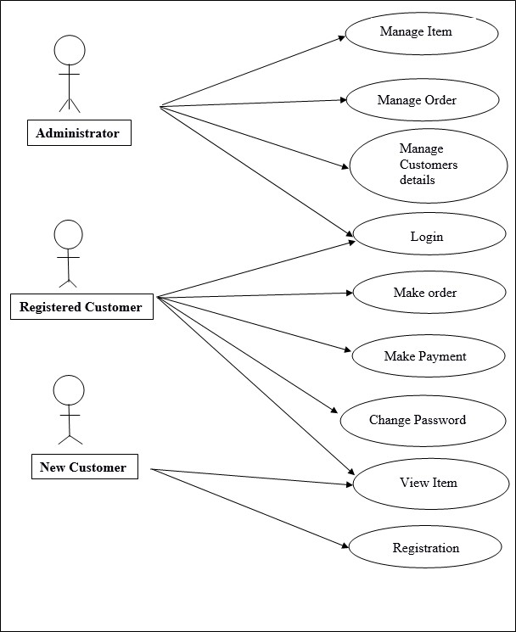

# Extended Use Cases

* + 1. **Sign up Section:** Main **Name:** Sign up

**Actors:** Common people.

**Purpose:** Sign up to the system

**Description:** The user enters his contact details to sign up to the system.

### Cross References: NONE

**Pre-Conditions:** NONE

**Successful Post Conditions:** Sign Up Successful

**Failure Post Conditions:** Sign Up Failed. Enter correct details.

### Alternative Course

Step 1: The user enters invalid login information

Step 2: The system displays an error and asks the user to reenter the information.

* + 1. **Login**

**Section:** Main

**Name:** Login

**Actors:** Administrator, Common people.

**Purpose:** Login to the system

**Description:** The user enters the username and password to login to the system.

### Cross References: NONE

**Pre-Conditions:** NONE

**Successful Post Conditions:** User is logged in to the system

**Failure Post Conditions:** Login Failed

### Alternative Course

Step 1: The user enters invalid login information

Step 2: The system displays an error and asks the user to re-enter the information.

# CHAPTER 6: DFD (DATA FLOW DIAGRAM)

Sponsor

Management

Enquiry

Management

Login Management

* 1. **Zero Level DFD – Online Shopping System**

Event

Management

**Online**

**Shopping System**

Login Management

Order Management

System User Management

Shopping Management

Payment Management

Customer Management

# First Level DFD - Online Shopping System

**Online Shopping System**

System User Management

Generate system User Report

Login Management

Check User Login Details

Shipment Management

Generate Shipment Report

Product Management

Generate Product

Report

Shopping Cart Management

Generate Shopping Cart Report

Shopping Management

Generate Shopping Report

* 1. **Second Level DFD –Online Shopping System**

Login to

System

Check Role of Access

Forgot Password

Check

credential

Send

Email to user

**Manage**

**Modules**

Manage Cart

Details

Manage User Permissi

-on

Manage Login Report

Manage Order Profiles

Manage roles of Users

Manage Systems Admin

Manage Customer Details

Manage Payment Details

Manage Category Details

Manage Product Details

Admin

# CHAPTER 7: DATABASE DESIGN

* + 1. **Customer**

|  |  |  |  |
| --- | --- | --- | --- |
| **Name** | **Type** | **Size** | **Description** |
| Id | Integer | 1 | Id of the Customer |
| Name | String | 30 | Name of the  Customer |
| Contact | Integer | 50 | Contact of the  Customer |
| Location | String | 12 | Location of the  Customer |
| Email | String | 30 | Email of the  customer |

# Customer Request

|  |  |  |  |
| --- | --- | --- | --- |
| **Name** | **Type** | **Size** | **Description** |
| Categories | String | 3 | Type of the event |
| Services | String | 10 | Type of service |
| Product | String | 30 | Type of product |
| Location | String | 25 | Location of  venue |

* + 1. **Account**

|  |  |  |  |
| --- | --- | --- | --- |
| **Name** | **Type** | **Size** | **Description** |
| Id | Integer | 4 | Id of the  Customer |
| Password | String | 30 | Password of the  Customer |
| Email | String | 20 | Email of the  customer |

# Admin

|  |  |  |  |
| --- | --- | --- | --- |
| **Name** | **Type** | **Size** | **Description** |
| Id | Integer | 4 | Id of the  Admin |
| Password | String | 30 | Password of  the Admin |
| Email | String | 20 | Email of the  Admin |

# CHAPTER 8: ER DIAGRAM

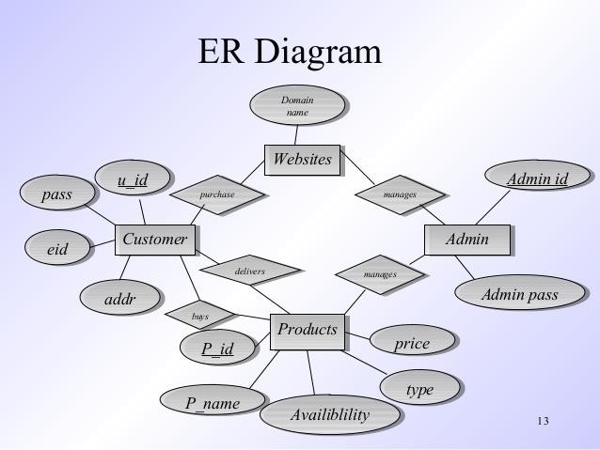

# CHAPTER 9: SCREENSHOTS

1. **HOME PAGE**

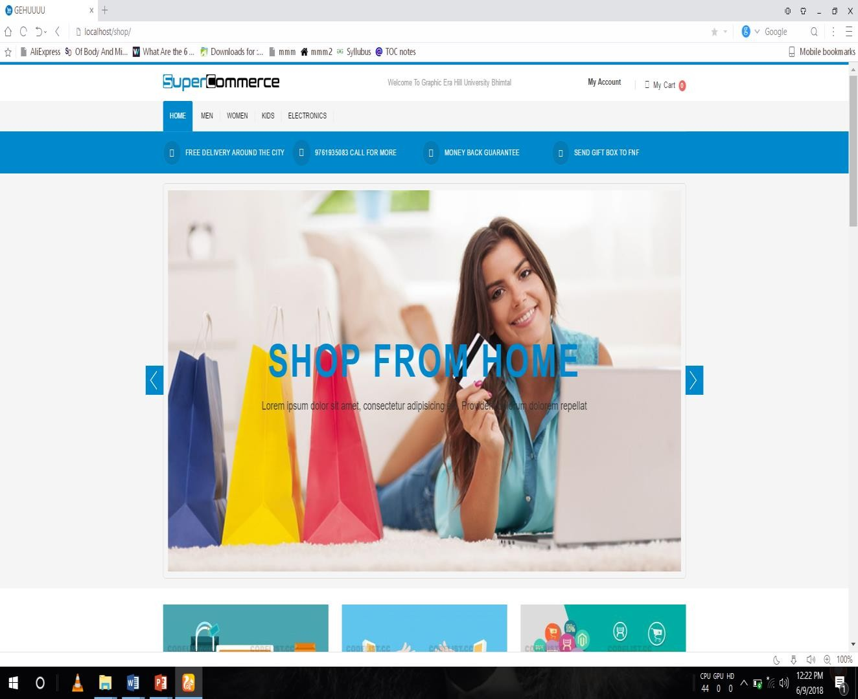

# PRODUCT PAGE

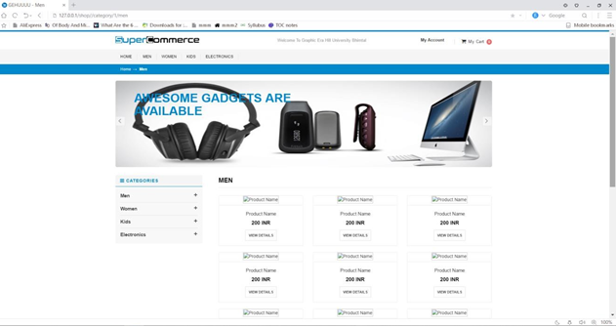

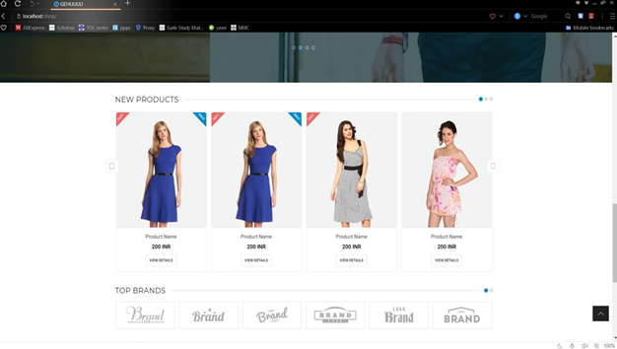

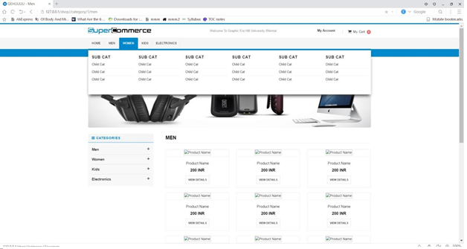

1. **SIGN IN PAGE**

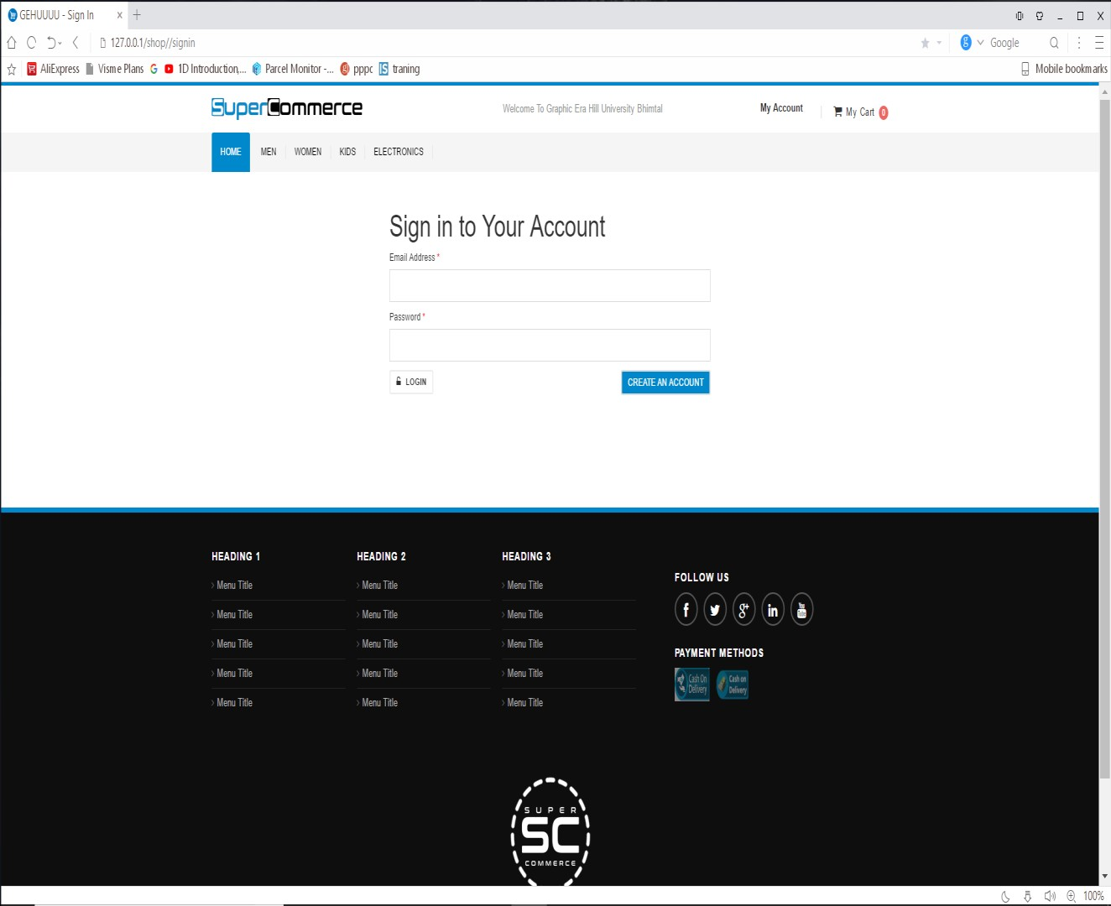

# SIGN UP PAGE

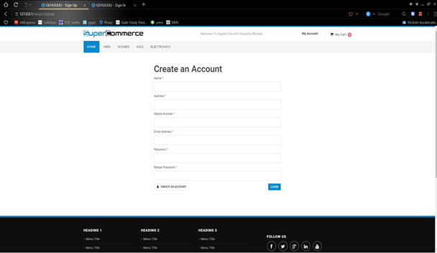

1. **ADMIN PANEL**

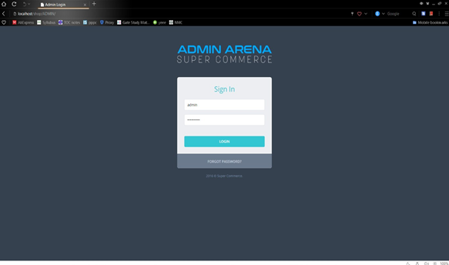

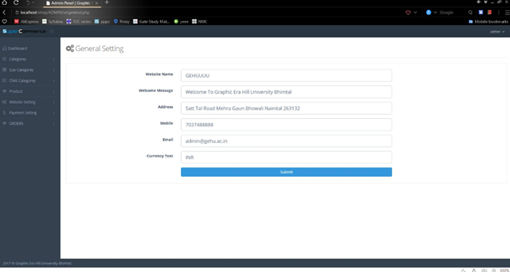

# INFO PAGE

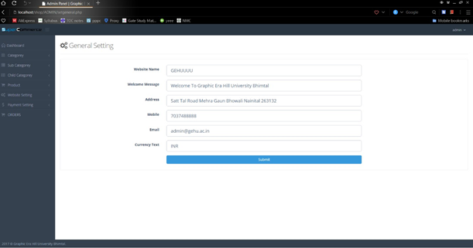

**CHAPTER 10: TESTING STRATEGIES**

## Test Case 1

|  |  |  |  |  |  |  |
| --- | --- | --- | --- | --- | --- | --- |
| Test Case  Id: | Test  Scenario: | Test Steps: | Test Data: | Expected  Result: | Actual  Result: | Pass/Fail |
| TCID | Check customer login with valid data | 1.Go to site 2, Enter user id   1. Enter user password 2. Check   submit | User id: 123 User password: R6524 | User should login into application. | As expected | Pass |

**Test Case 2**

|  |  |  |  |  |  |  |
| --- | --- | --- | --- | --- | --- | --- |
| Test Case  Id: | Test  Scenario: | Test Steps: | Test Data: | Expected  Result: | Actual  Result: | Pass/Fail |
| TCID2 | Check  customer | 1. Go to  site | User id:  User | User  should not | As  expected | Pass |

|  |  |  |  |  |  |  |
| --- | --- | --- | --- | --- | --- | --- |
|  | login with invalid data | 1. Enter user id 2. Enter user password 3. Check   submit | password: 567h | login into application. |  |  |

## Test Case 3

|  |  |  |  |  |  |  |
| --- | --- | --- | --- | --- | --- | --- |
| Test Case  Id: | Test  Scenario: | Test Steps: | Test Data: | Expected  Result: | Actual  Result: | Pass/Fail: |
| TCID2 | Test user forget password | 1. Go to site 2. Enter user id 3. Enter user password: “password forgot” 4.  Enter | User id: 3456 User password : “Empty” Verificati on code: 8899 Enter new | User should not login into application. | As expected | Pass |

|  |  |  |  |  |  |  |
| --- | --- | --- | --- | --- | --- | --- |
|  |  | verification code 5.  Enter new password.  6. Check  submit | password : bhalli |  |  |  |

**Test Case 4**

|  |  |  |  |  |  |  |
| --- | --- | --- | --- | --- | --- | --- |
| Test  Case Id: | Test  Scenario: | Test Steps: | Test Data: | Expected  Result: | Actual  Result: | Pass/Fail: |
| TCID4 | Test the submit button | 1. Go to site 2. Navigate to login/signup page. 3. Fill the form according to the format.   4. Click  submit. | User name: NOMAN Akhter Email: 13005065023@u  mt.edu.pk Password: 345y | The user can make new account on this web application | As expected | Pass |

## Test Case 5

|  |  |  |  |  |  |  |
| --- | --- | --- | --- | --- | --- | --- |
| Test Case  Id: | Test  Scenario: | Test Steps: | Test Data: | Expected  Result: | Actual  Result: | Pass/Fail: |
| TCID5 | To view | 1. Go to |  | User can | As | Pass |
|  | the timing | site 2. | see the | expected |  |
|  | slots of | Click on | timing slots |  |  |
|  | venue. | hall name. | of venue. |  |  |
|  |  | 3. Check |  |  |  |
|  |  | timing |  |  |  |
|  |  | slots |  |  |  |

**Test Case 6**

|  |  |  |  |  |  |  |
| --- | --- | --- | --- | --- | --- | --- |
| Test Case  Id: | Test  Scenario: | Test Steps: | Test Data: | Expected  Result: | Actual  Result: | Pass/Fail: |
| TCID5 | To view | 1. Go to |  | User can see | As | Pass |
|  | the | site 2. | packages of | expected |  |
|  | packages | Click on | entire |  |  |
|  | venue | hall name. | venue/hall. |  |  |
|  |  | 3. Check |  |  |  |
|  |  | packages |  |  |  |

# CHAPTER 11: RESULT/OUTPUT/STATISTICS

. This section includes the results of the above comparison

# %completion.

We have completed our project 100%. We have

met all the functional requirements that we discussed.

# %accuracy

Our project is working 100% accurate. It fulfills all the functional and non functional requirements as we promised.

# %correctness

As we have tested all the requirements and made their test cases mentioned and clear all the mistakes so now our project is 100% correct.

# CHAPTER 12: CONCLUSION

Our project is only a humble venture to satisfy the needs to manage their project work. Several user friendly coding have also adopted. This package shall prove to be a powerful package in satisfy all requirements of the user. The objective of software planning is to provide a frame work that enable the manager to make reasonable estimate made within a limited time frame at the beginning of the software project and should be update regularly as the project regularly.

At the end it is concluded that we have made effort on following points…

* A description of background and context of the project and its relation to work already done in the area.
* Made statement of the aims and objectives of the project.
* The description of the purpose, scope and applicability.
* We define the project on which we are working in project.
* We describe the requirement specifications of the system and actions that can be done on these things.
* We designed user interface and security issues related to system.
* Finally the system is implemented and tested according to the test cases.

# CHAPTER 13: FUTURE WORK

Purchasing and selling products and services over the internet without the need of going physically to the market is what online shopping all about. Online shopping is just like a retail store shopping that we do by going to the market, but it is done through the internet. Online shopping has made shopping painless and added more fun. Online stores offer product description, pictures, comparisons, price and much more. Few examples of these are Amazon.com, ebay.com, [framt.com](http://www.framt.com/) and the benefits of online shopping is that by having direct access to

consumer ,the online stores can offer products that cater to the needs of consumer ,cookies can be used for tracking the customer selection over the internet or what is of their interest when they visit the site again . Online shopping makes use of digital technology for managing the flow of information, products, and payment between consumer, site owners and suppliers. Online shopping can be either B2B (business to business) or B2C (business to consumer). Online Shopping is one of the important facility provided in online shopping, this lets customer to browse different goods and services and once they select an item to purchase they can place the item in shopping cart, and continue browsing till the final selection. Customers can even remove the items from shopping cart that were selected earlier before they place the final order. It reminds us of shopping basket that we carry in departmental store.

# References:

[**http://www.slideshare.net/DYogendraRao/online-shopping system24592836**](http://www.slideshare.net/DYogendraRao/online-shopping%20system24592836)

[**http://recursostic.education.es/secudaria/edad/3esoingles/3quincena9/impresos**](http://recursostic.education.es/secudaria/edad/3esoingles/3quincena9/impresos/shopping_trends)

[**/shopping_trends**](http://recursostic.education.es/secudaria/edad/3esoingles/3quincena9/impresos/shopping_trends)

[**http://en.wikipedia.org/wiki/Online-shopping**](http://en.wikipedia.org/wiki/Online-shopping)

[**https://react.dev/**](https://react.dev/)

**https://www.javatpoint.com/spring-boot-tutorial**